User guide

Contents

Setup: 2

Please read all the README.md in: 2

Usage: 4

User signup: 4

Login 6

Landing page 7

Search movie page 8

Search movie by title 8

Search movie by categories 9

Search movie by both 10

Movie detail popup 10

Rate movie popup 11

Rate movie 11

My favourite 12

Demo 13

Download 13

## Setup:

Please read all the README.md in:

\README.md

\database\README.md

\server\README.md

\web\README.md

Global setup:

Server setup:

Web setup:

Database setup:

## Usage:

User signup:

1. 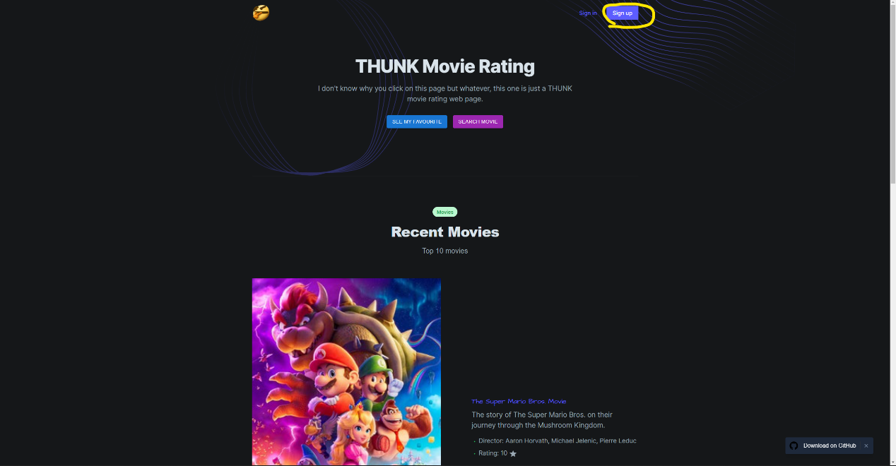
2. 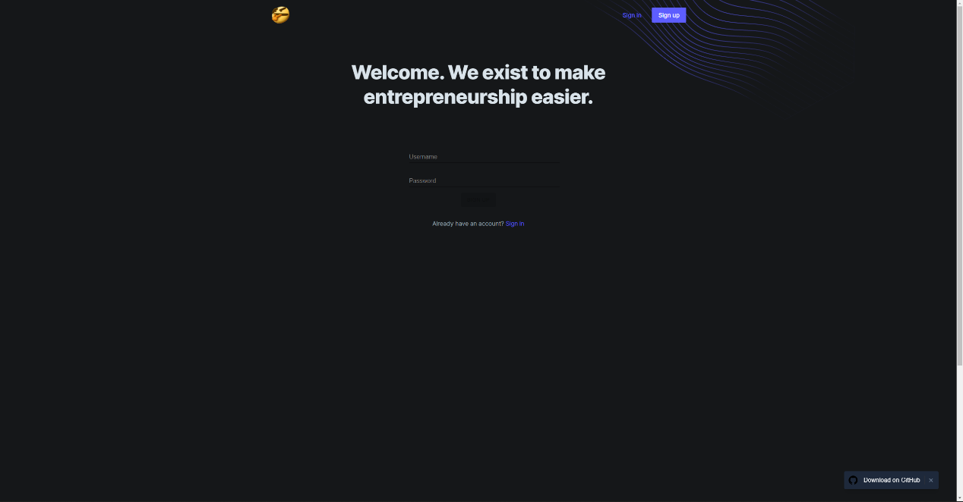
3. 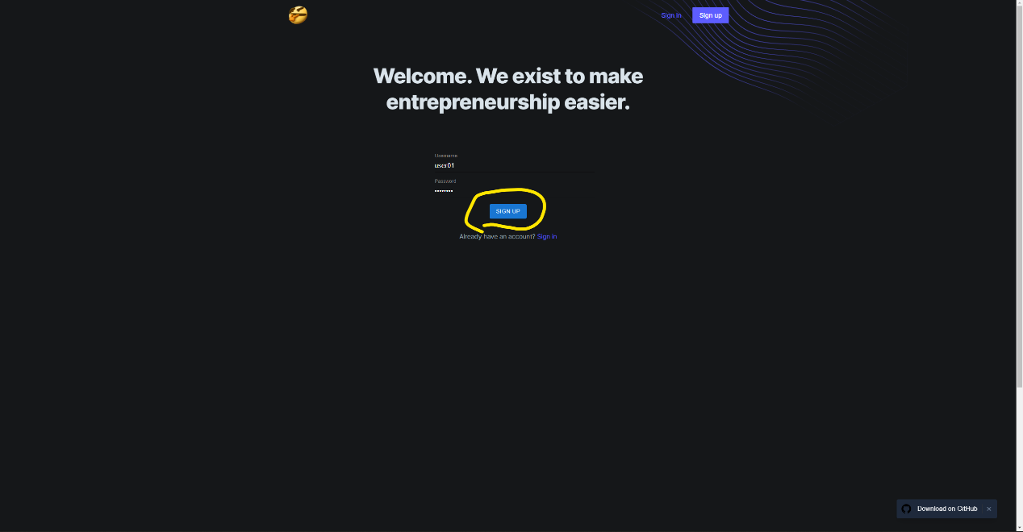
   * By entering the username, the page will check whether the username can use.

Login

1. 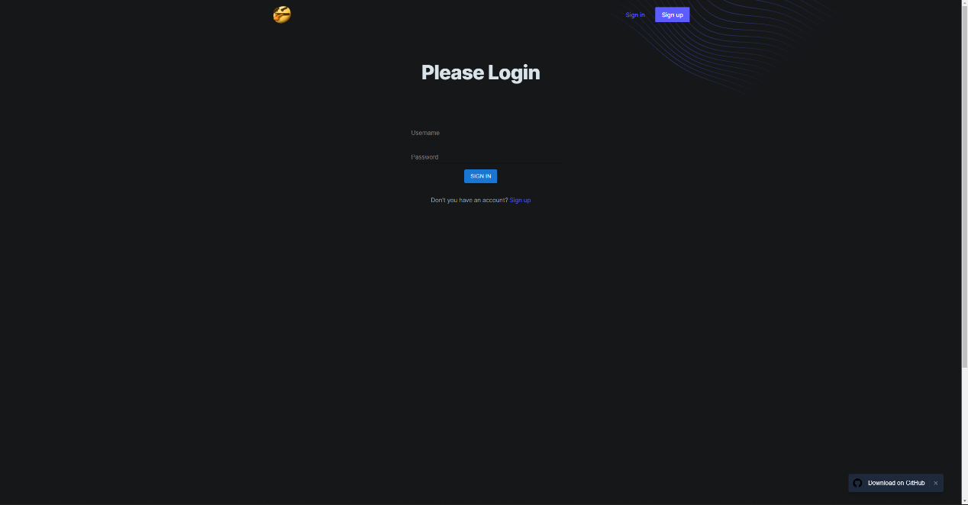
2. 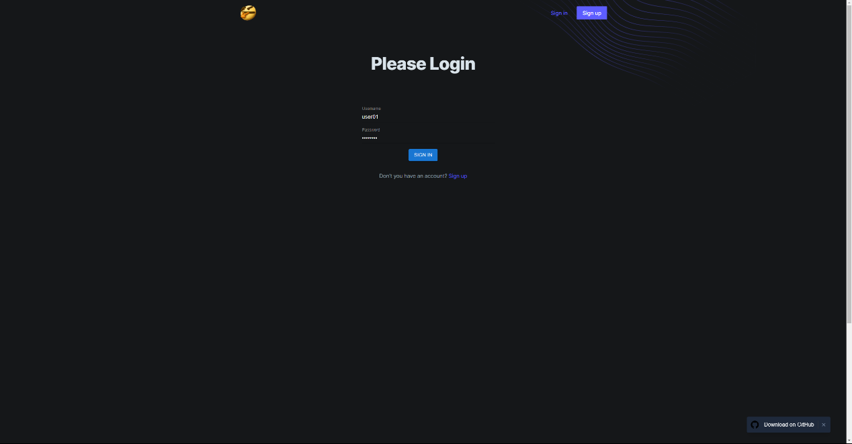
   * Only when the user enter the exact same username and password can be login.

Landing page

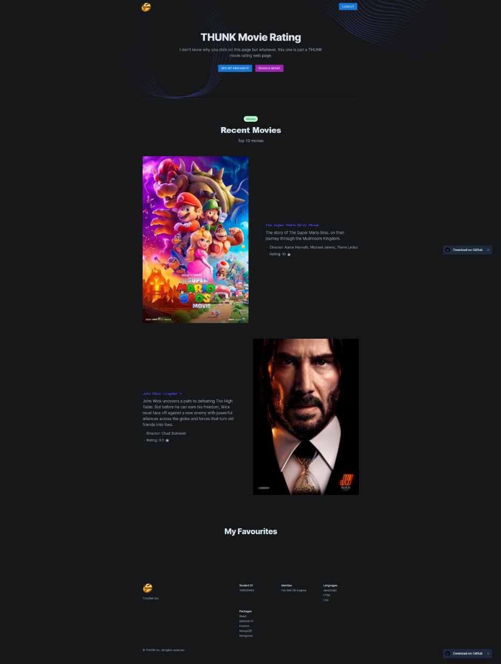

* “SEARCH MOVIE” button will redirect to search movie page
* “SEE MY FAVOURITE” button will scroll down to “My Favorites” section.

Search movie page

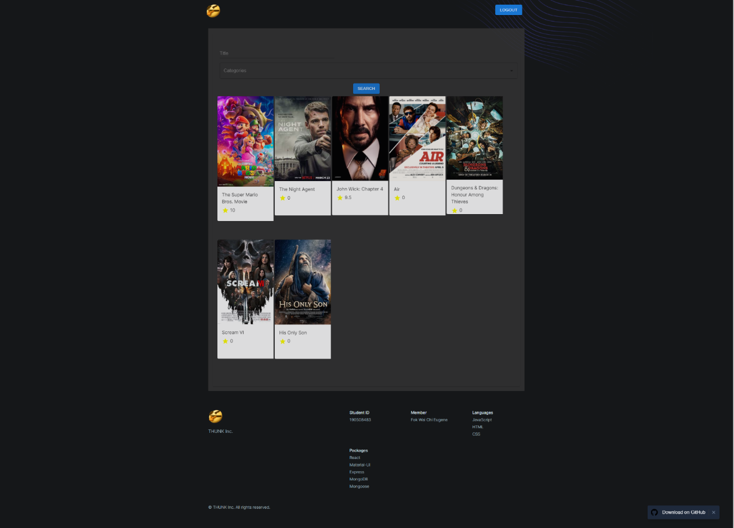

Search movie by title

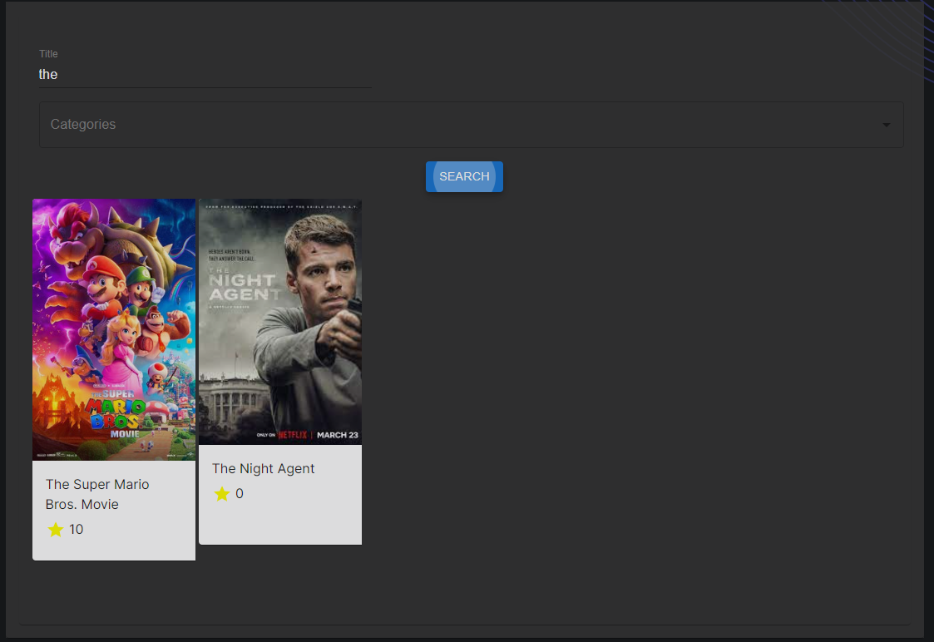

* The string that input in the “Title” field and click “SEARCH” button, all the movies contain the string input in the “Title” field will appear.

Search movie by categories

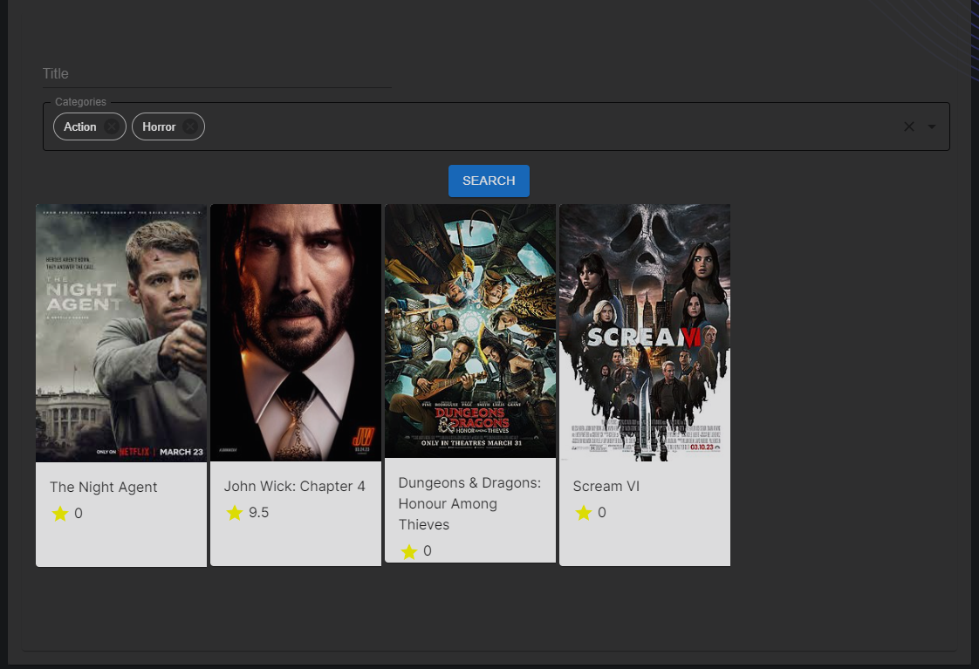

* Users may search movies by selecting the categories field. In the categories field, beside clicking the option, user may type in something like “in”, the option list will show all options contain “in”.
* By clicking the “SEARCH” button, all the movies containing the categories selected will be shown.

Search movie by both

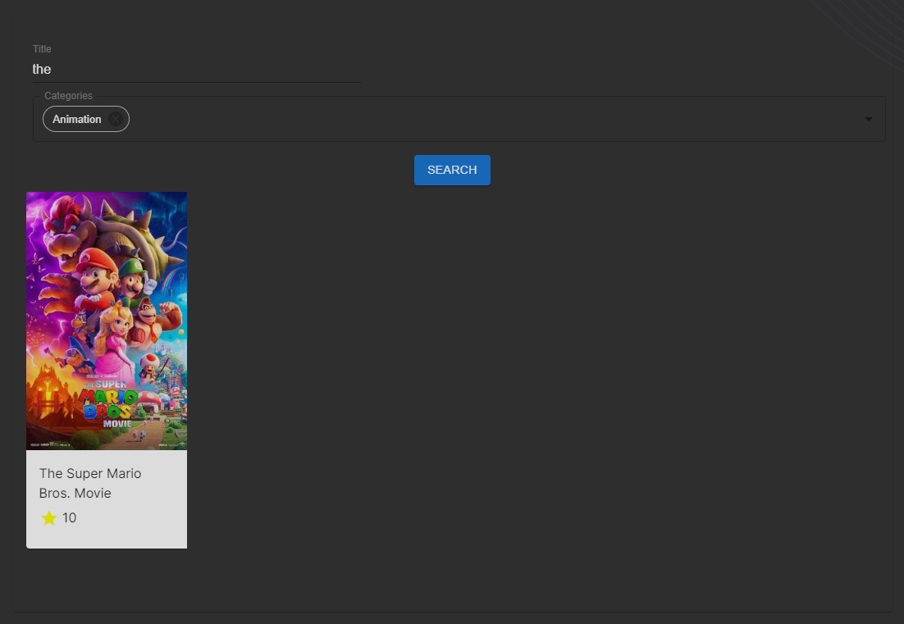

Movie detail popup

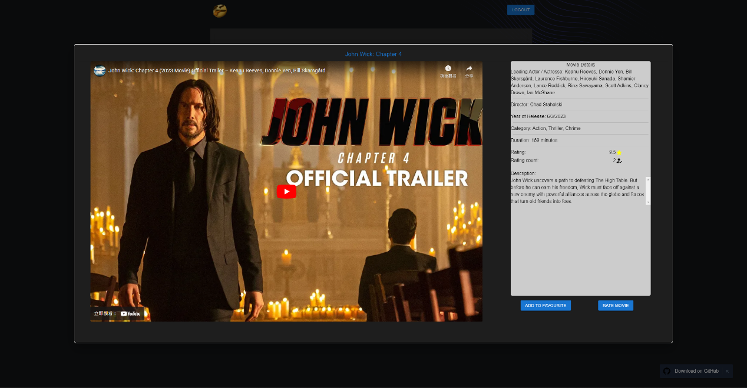

* To add movie to my favorite, by clicking “ADD TO FAVOURITE” button.
* To rate the movie, by clicking “RATE MOVIE” button.
* User must login to be able to rate the movie and add to favorite.

Rate movie popup

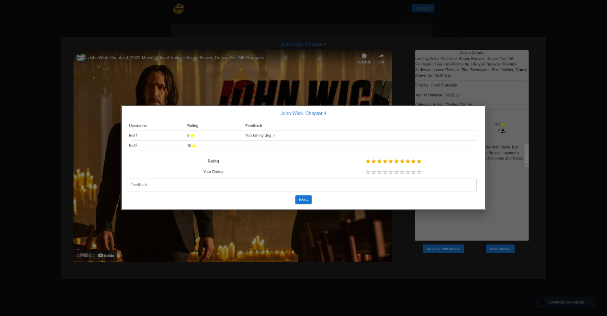

Rate movie

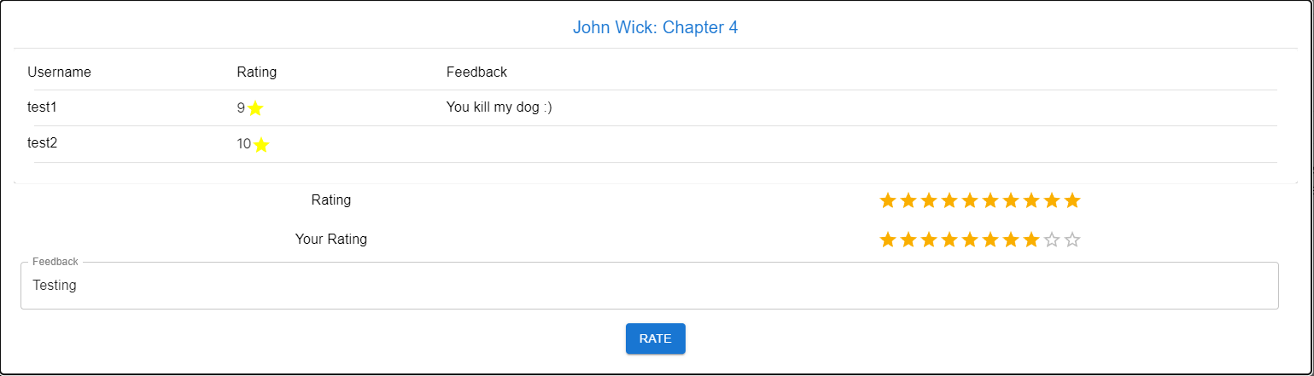

* To give ratings, by clicking the stars, and can give the feedback as well, then click the “RATE” button.
* After rate the movie, you may click back the same movie and click the “RATE MOVIE” button again, you can view the feedback and rating you rated before, and you may edit the score and feedback by clicking the stars, and changing the text in the feedback field, then click “RATE” button to update it.
* The top section shows all the comments and ratings from other users.

My favourite

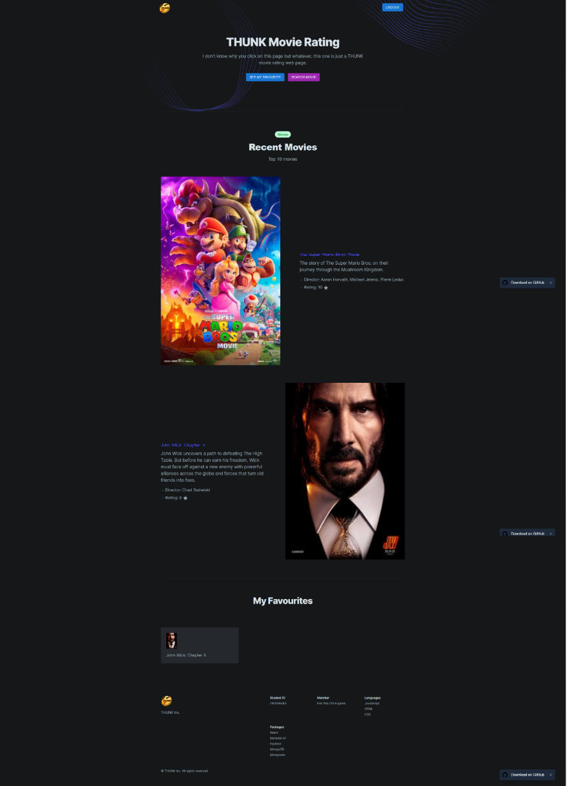



## Demo

* Database setup: <https://www.youtube.com/watch?v=9oQCCbyUwG4&list=PLQLH4CPMmDak9JgrjEndERCUYGJCOgUG-&index=1>
* Frontend and backend setup and web page demo: <https://www.youtube.com/watch?v=Mcrmahgf3bs&list=PLQLH4CPMmDak9JgrjEndERCUYGJCOgUG-&index=2>

## Download

* Github:

<https://github.com/Eugene-08/DIT5404-Modern-Web-Application-Development-Assignment/tree/main>